### Architect a Blockchain Supply Chain Solution - Part B

# Supply chain application To prove the authenticity of items using the Ethereum blockchain

The contract allows an item to progress through the steps described below, from Farmer to Consumer, keeping track of ownership changes and original information. In the initial plan, the actors were Farmer, Exchange, Seller and Buyer for a Vegetable supply chain. Updated the plan to adapt to the Coffee seed supply chain provided in the example.

## Activity Diagram

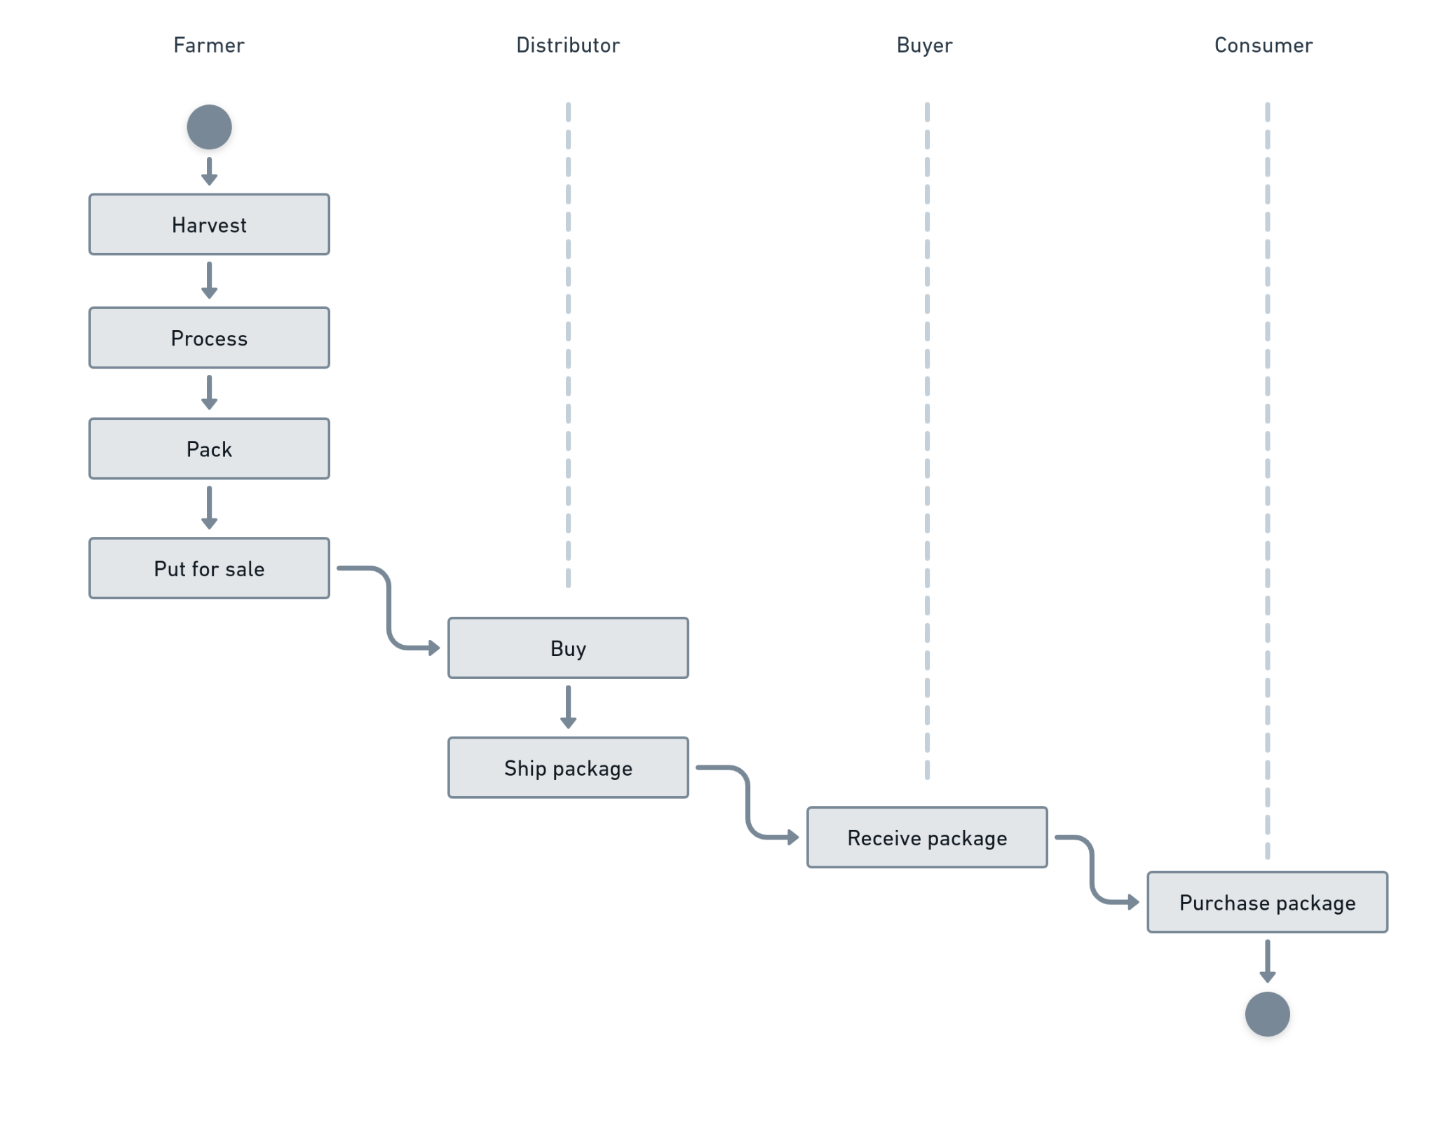

## Sequence Diagram

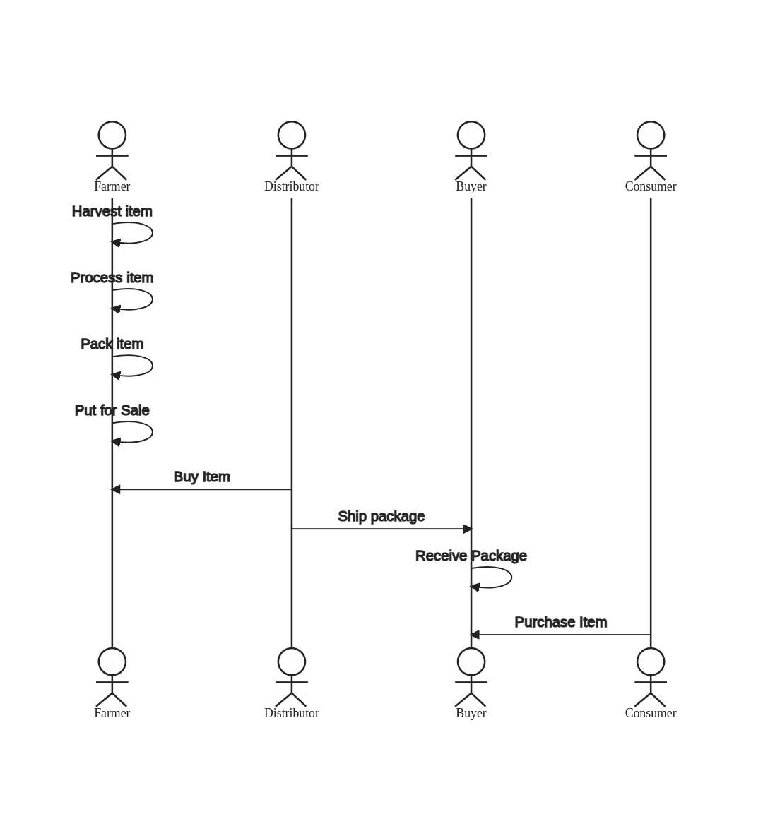

## State Diagram

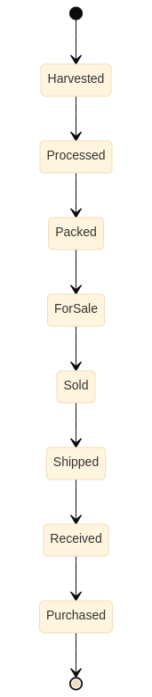

## Class diagram

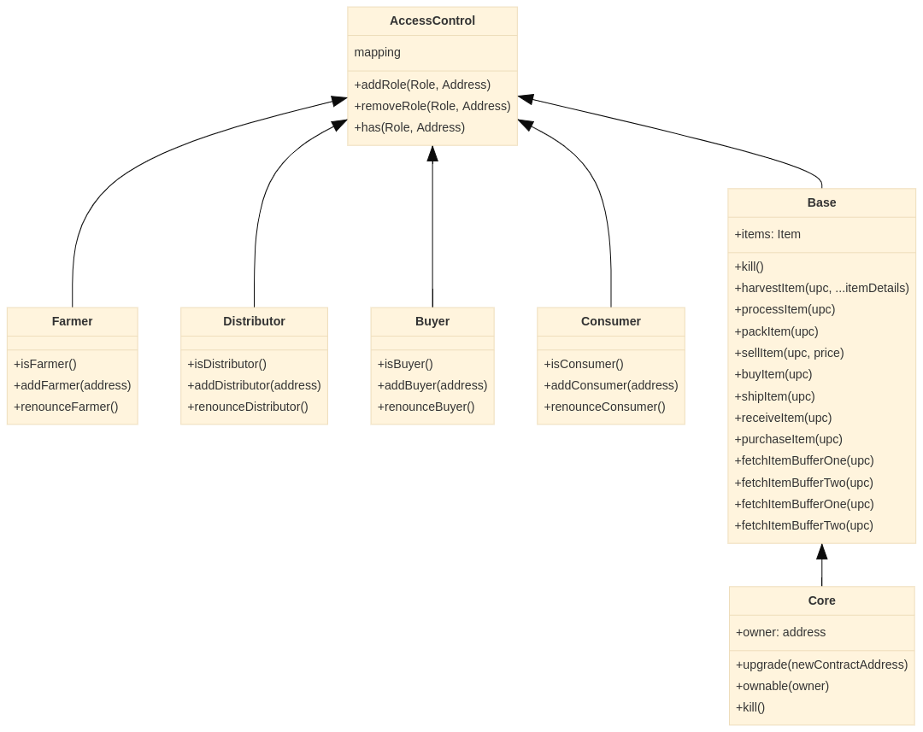

## Libraries used

The initial plan was to go ahead with OpenZepplin’s helpers to implement ERC20 based. However, since the sample code provided was already there, followed the sample codebase.

* Used web3 for frontend

## Versions

Node: v14.19.1

Truffle: v4.1.17

Web3: web3@0.20.1

Truffle Contract: @truffle/contract@4.3.5

## Sample contracts and transactions on Etherscan

### Contracts

* [FarmerRole: 0xfff2894336e05467ee50aa2dcb4f5cc12a6ebc0f](https://rinkeby.etherscan.io/address/0xfff2894336e05467ee50aa2dcb4f5cc12a6ebc0f#events)
* [DistributorRole: 0x11eed5ccf62d3c4a770f08999432cbfd9871ad91](https://rinkeby.etherscan.io/address/0x11eed5ccf62d3c4a770f08999432cbfd9871ad91#events)
* [RetailerRole: 0x9e2ed19125420944a8797c4fa952a502cc494b00](https://rinkeby.etherscan.io/address/0x9e2ed19125420944a8797c4fa952a502cc494b00#events)
* [ConsumerRole: 0x29a1c2d658aeb7a5f5f1b568e58a666fcf2a6495](https://rinkeby.etherscan.io/address/0x29a1c2d658aeb7a5f5f1b568e58a666fcf2a6495#events)
* [SupplyChain: 0x8d9575a58217f0805dc930c9f1b4a8a41aadc0e3](https://rinkeby.etherscan.io/address/0x8d9575a58217f0805dc930c9f1b4a8a41aadc0e3#events)

### Transactions

* [Harvested: 0xa27c82ba4d42340558253c1a0f79141f03d8b3e090266a85e7d36710262513c5](https://rinkeby.etherscan.io/tx/0xa27c82ba4d42340558253c1a0f79141f03d8b3e090266a85e7d36710262513c5)
* [Processed: 0x3d406f0ec78d7a89fb6eb2e411abb0714fa144e073625149eeeb4cad2179cf3d](https://rinkeby.etherscan.io/tx/0x3d406f0ec78d7a89fb6eb2e411abb0714fa144e073625149eeeb4cad2179cf3d)
* [Packed: 0x1b78608361c409c6c206d783db9d1b26365689c7c278d04f9e769db33ad7c854](https://rinkeby.etherscan.io/tx/0x1b78608361c409c6c206d783db9d1b26365689c7c278d04f9e769db33ad7c854)
* [ForSale: 0x4c69c20dda840627dcbb7e60f45af3c6ee6f9ff7bd1dd5a952098a2c632905d3](https://rinkeby.etherscan.io/tx/0x4c69c20dda840627dcbb7e60f45af3c6ee6f9ff7bd1dd5a952098a2c632905d3)
* [Sold: 0x76456be6303c1d0b100aa9f7729725990848a26f759fe7e7ea28d537d0724b85](https://rinkeby.etherscan.io/tx/0x76456be6303c1d0b100aa9f7729725990848a26f759fe7e7ea28d537d0724b85)
* [Shipped: 0x48313928aa6f14ad838f5008a5d5b92d25b0b58ed04c5083684ee68cf264a497](https://rinkeby.etherscan.io/tx/0x48313928aa6f14ad838f5008a5d5b92d25b0b58ed04c5083684ee68cf264a497)
* [Received: 0x6a51ed830605a332b84da41573916e205715212e916fa9f51ecae5bd70aa5696](https://rinkeby.etherscan.io/tx/0x6a51ed830605a332b84da41573916e205715212e916fa9f51ecae5bd70aa5696)
* [Purchased: 0xb961badf46d11dbce4f20043d73b47d3f86b96420428c502f816532bb71bdaa8](https://rinkeby.etherscan.io/tx/0xb961badf46d11dbce4f20043d73b47d3f86b96420428c502f816532bb71bdaa8)